**Lab 6: Simulate ADD Operation**

# Objectives:

* Understand Machine Instructions and their role in execution.



* Define Instruction Format and its structure.
* Identify Fields of Instructions like opcode and operands.
* Execute Microinstruction Sequence step by step.
* Perform Addition of Two Numbers using basic instructions.

# Essential Tools in Our Lab:

* **Computer System:** The main machine
* **CPU Sim**: CPU Sim is a tool used for simulating simple CPU architectures, helping students understand processor design, instruction execution, and debugging.



**Introduction to CPU Sim**

program START: INP

STA NUM INP

ADD NUM OUT

HLT

NUM: .data 1 0

# Basic Machine Instructions

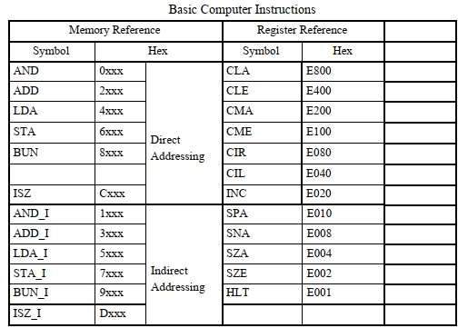



1. Make instructions according to Code. First make a instructions for **INP**

**First** make a format of instruction by adding opcode according to given address.

# Input

OPCODE: F800

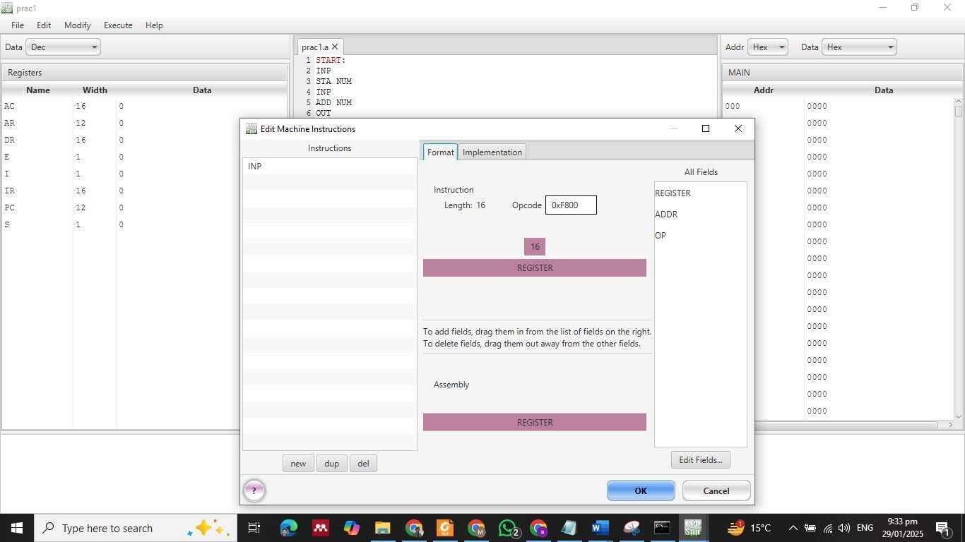

1. Second make a instructions for Microinstructions for input and set buffer.

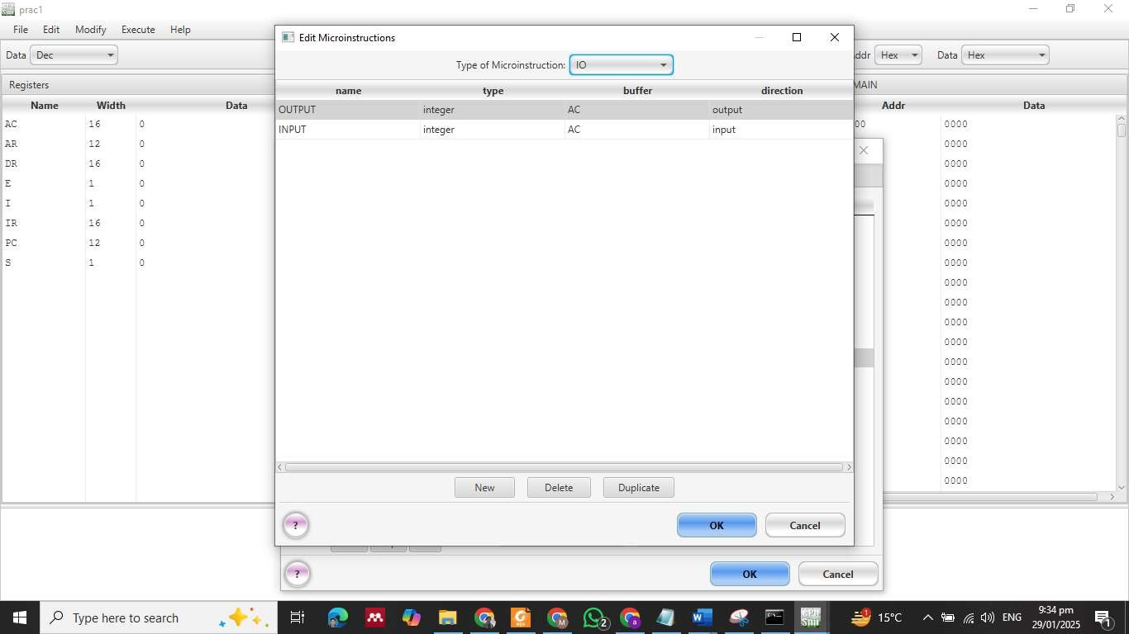



# Output:

OPCODE: F400

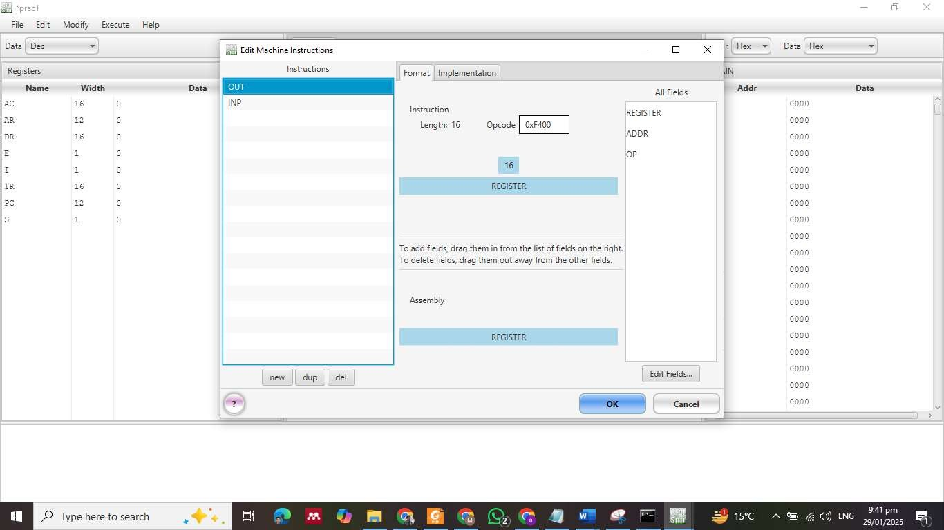

**Halt**

OPCODE: E001

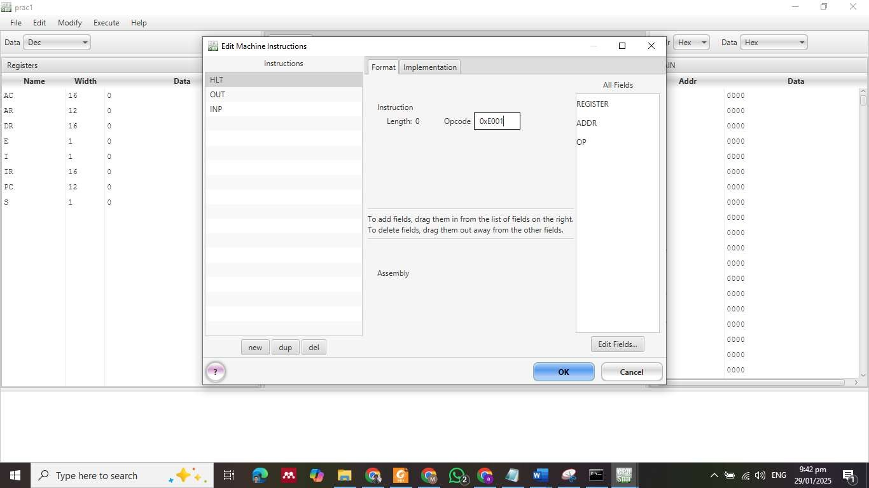



Set condition bit, for halt that is **S**

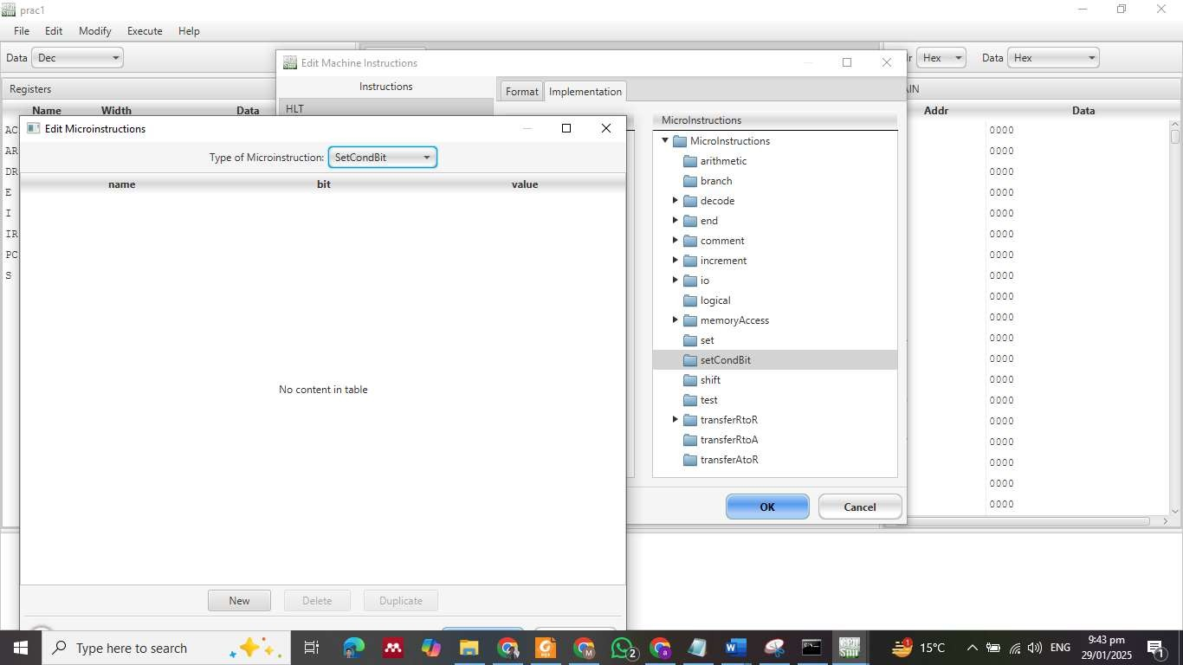

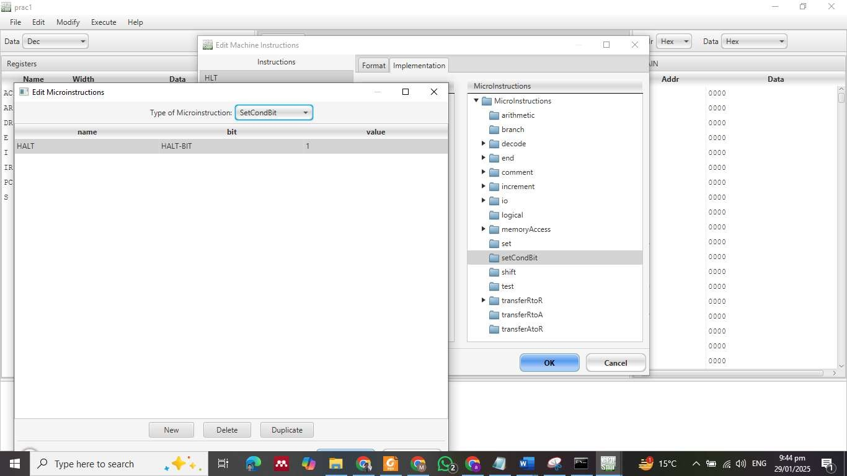



**STA OPCODE: 6**

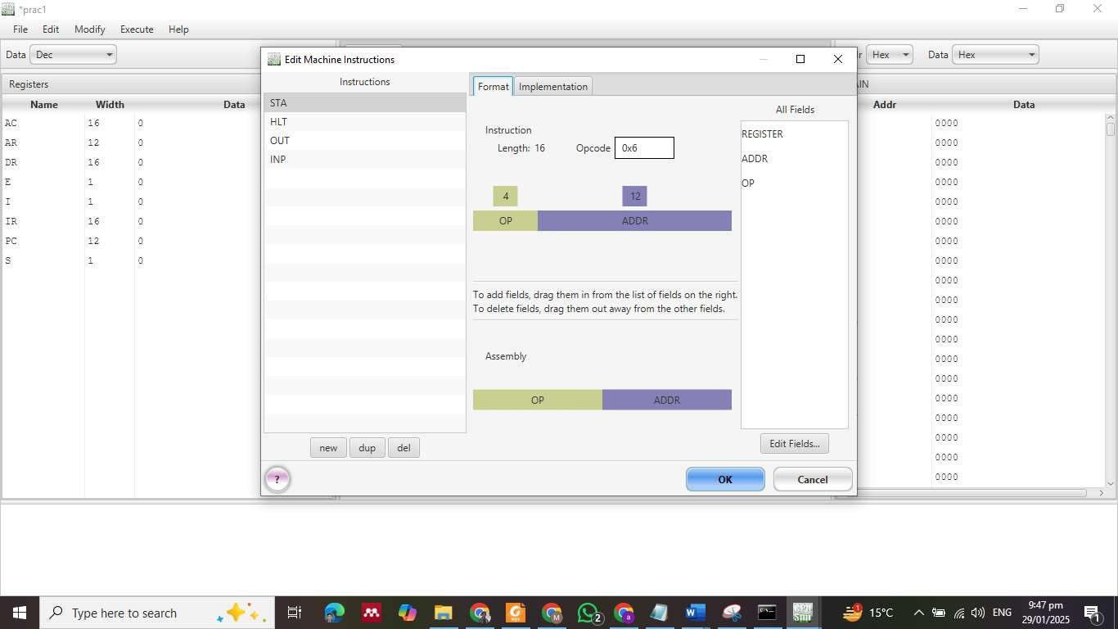

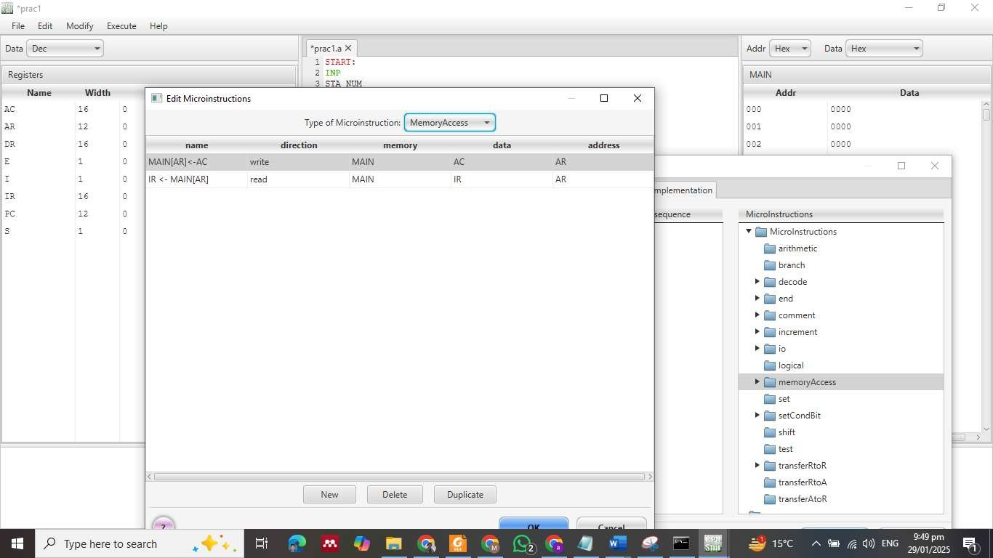



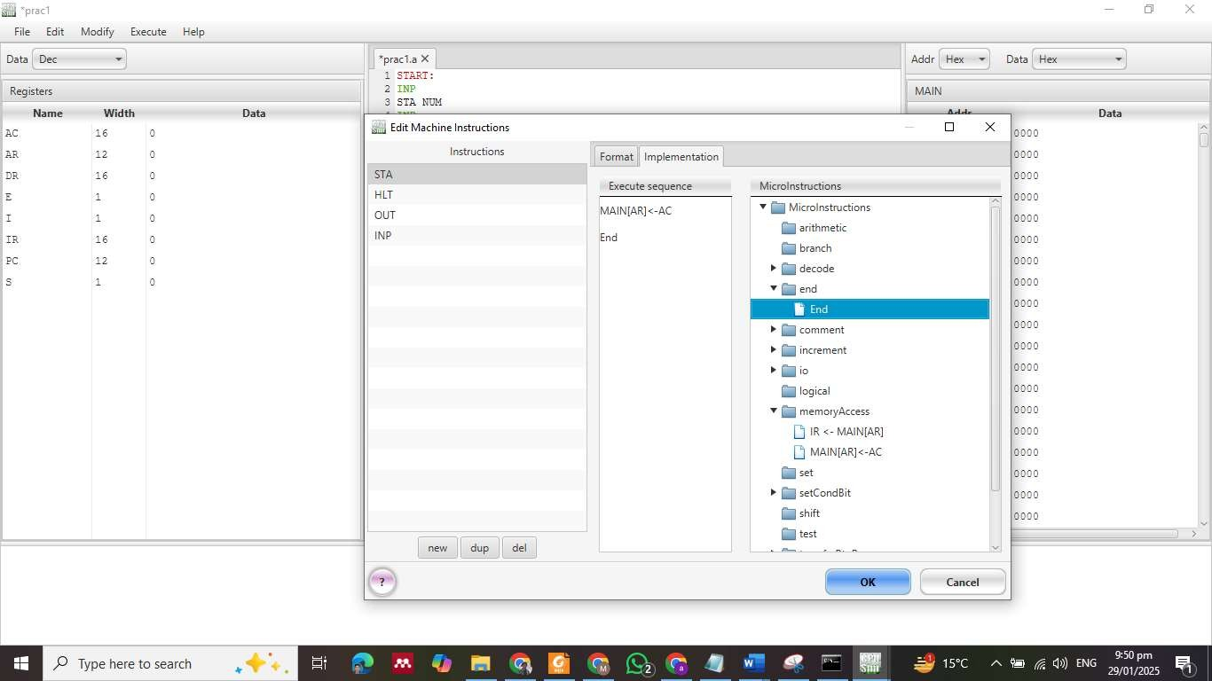

**ADD**

OPCODE: 2

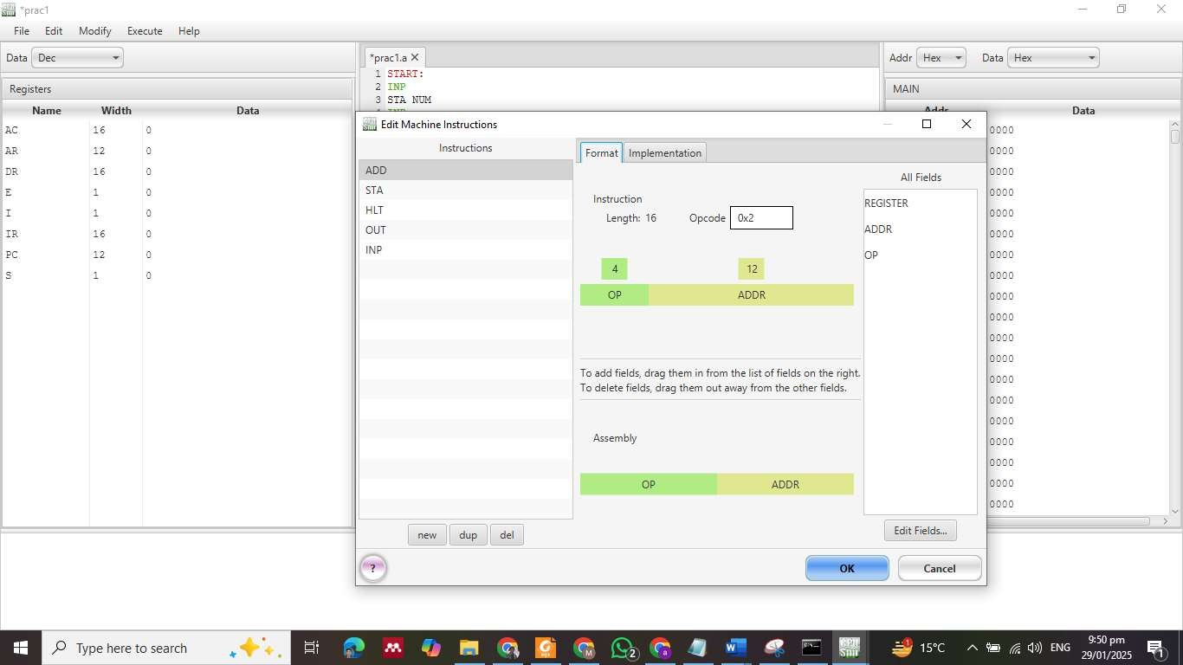



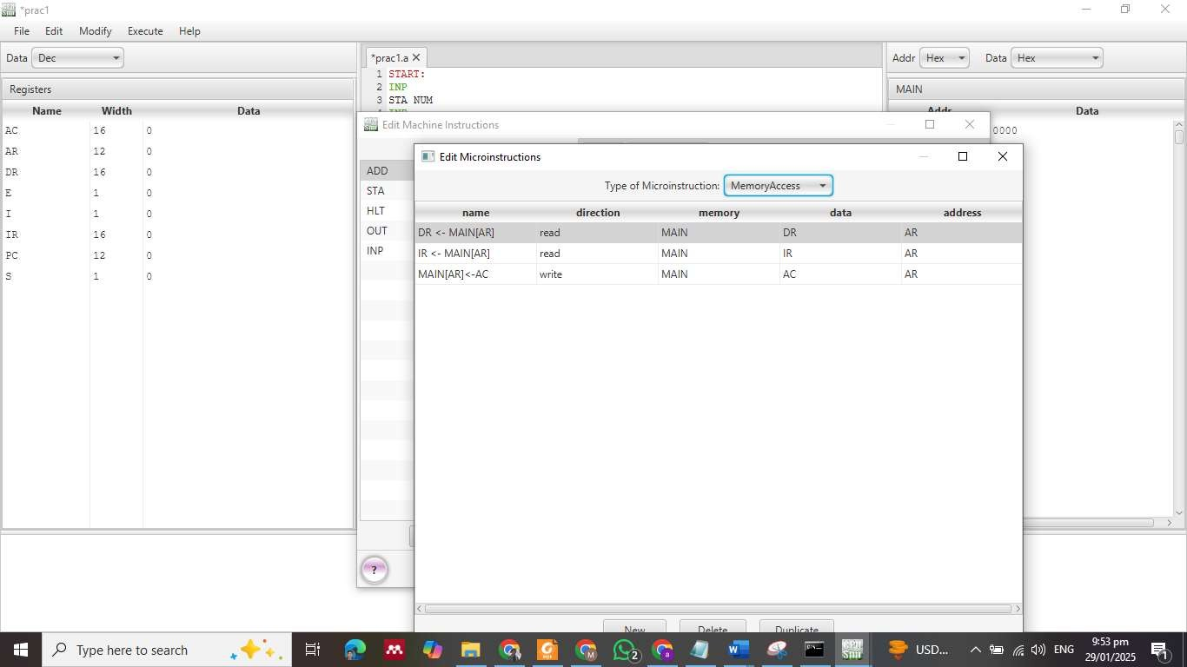

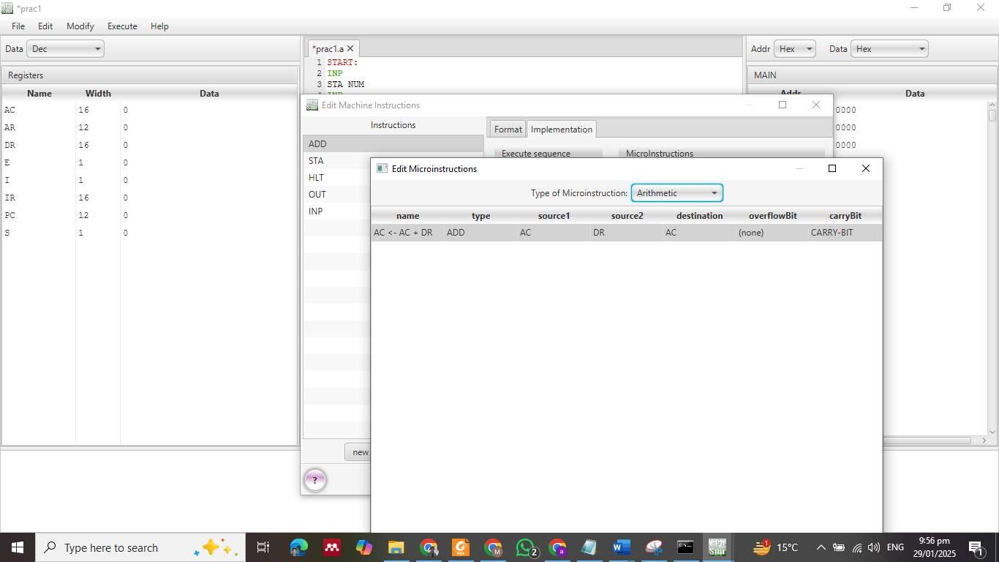



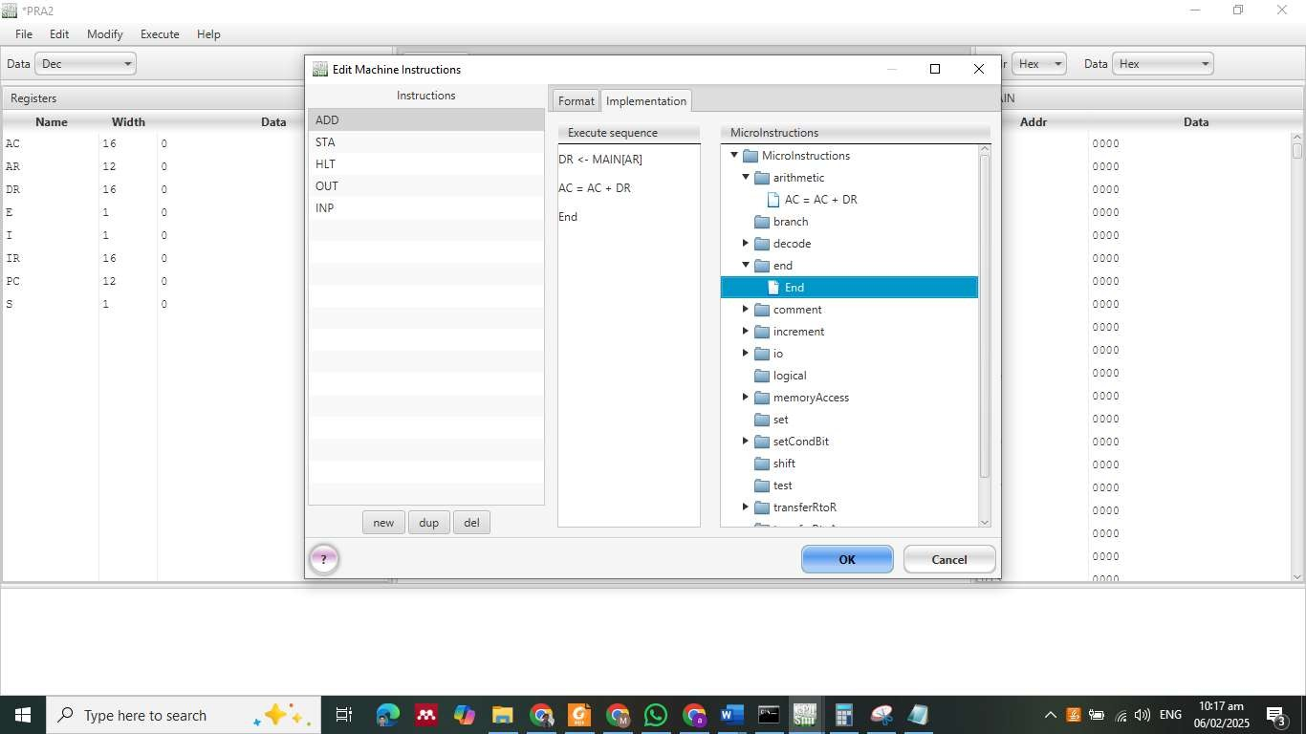

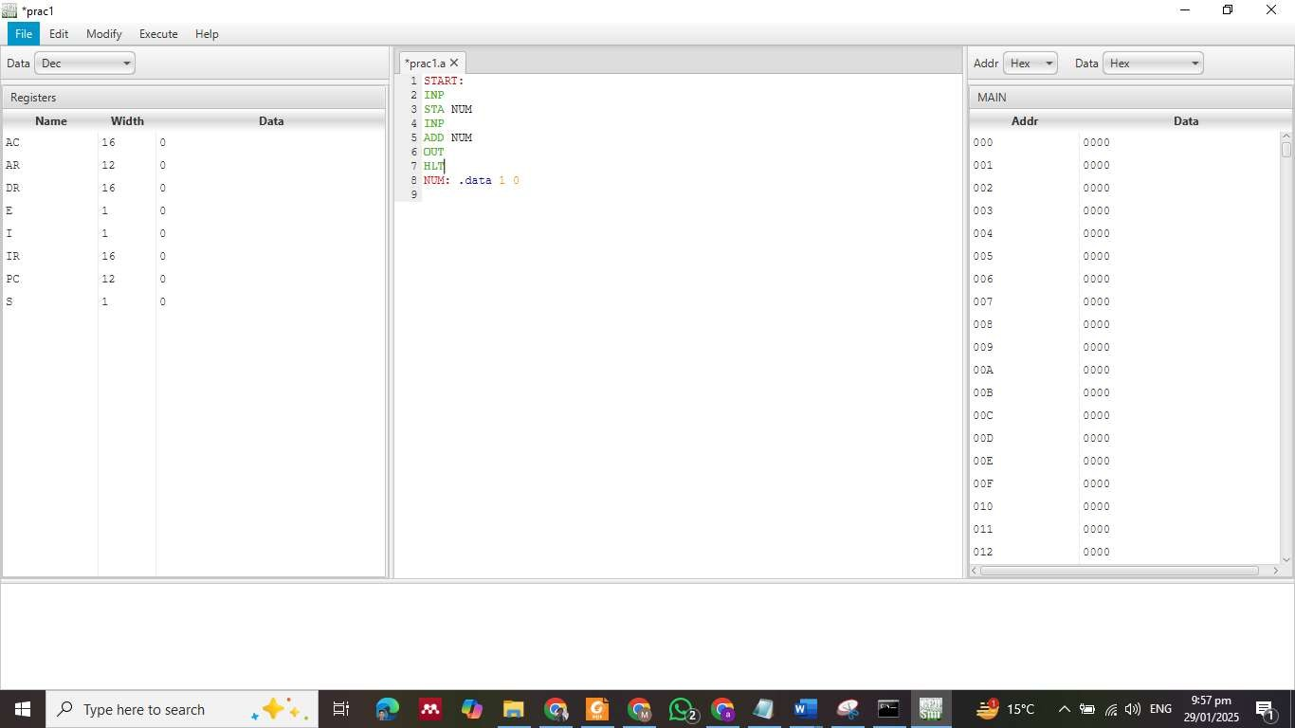

1. Execute the instructions



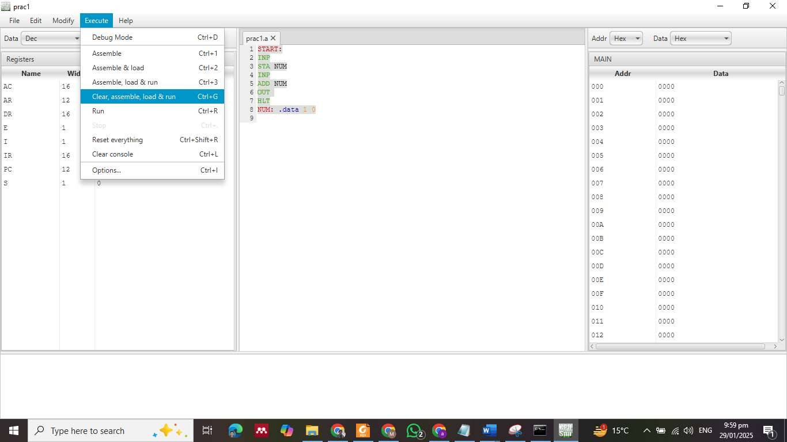

1. Enter inputs of numbers

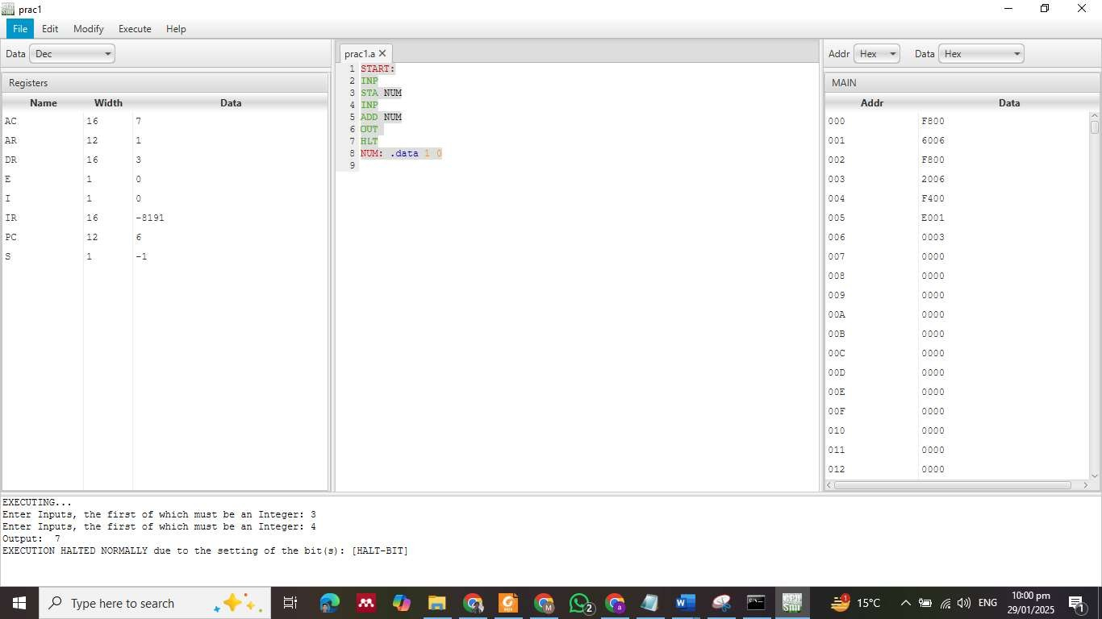

**LAB TASKS**

**Task 1:**

Accept **three numbers** as input and compute their sum.

### **Task 2:**

### **Add Two Numbers Stored in Memory (Predefined Values).**

**Task 3:**

Add a Number to Itself (Double a Value)